Data Visualizations
Reports can be accessed from the Project Overview page of the relevant project. To access the Project Overview page select the project in the 'Projects' drop down menu (see Illustration 1: The Projects drop down menu).
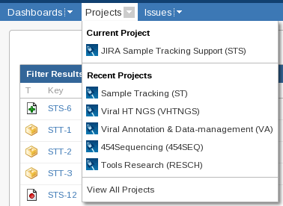
Illustration 1: The Projects drop down menu
The available reports are listed in the 'Reports' drop down menu in the 'Summary' tab of the Project Overview page (see Illustration 2: The Reports drop down menu).
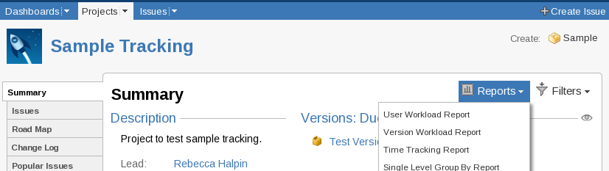
Illustration 2: The Reports drop down menu

Storing Charts and Reports
JIRA doesn't have any native way to store charts or their settings. The page with the chart can be printed as a PDF to save a particular instance, re-creating a chart as it would have looked on a certain date is not simple and so it is more reliable to store a copy at the time than to try and recreate it later.
If there is a graph that is useful to generate regularly the settings can be saved by bookmarking the page that the graph is shown on. Returning to the bookmarked page will cause the graph to be re-drawn with the current information.

Generating Charts

Creating a Pie Chart
(of the number of samples in each state)
Like all charts and reports 'Pie Charts' are created from the 'Reports' drop down menu in the 'Summary' tab of the Project Overview page (see Illustration 3: Pie Chart Report in menu and Pie Chart Report configuration page). Once the type of report has been selected a configuration page is displayed (also shown in Illustration 3).
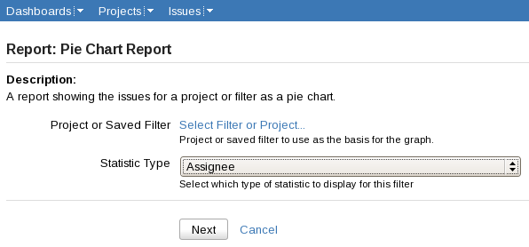
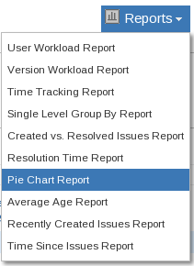
Illustration 3: Pie Chart Report in menu and Pie Chart Report configuration page
For a pie chart there are two configuration options, 'Project or Saved Filter' and 'Statistic Type'. These select which issues the pie chart will represent and how the chart will be divided respectively.
Project or Saved Filter:
This can be set to project (to include all the issues and sub-tasks in the project), or a filter that selects only the issues required. Clicking on the link for 'Select Filter or Project' will open a new window containing the Filter or Project Picker dialog (see Illustration 4: Project / Filter selection dialog).

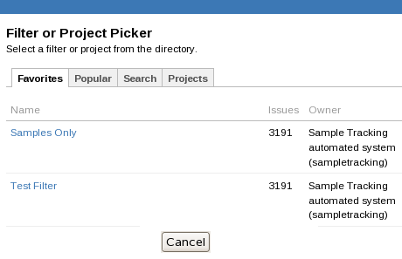
Illustration 4: Project / Filter selection dialog
The tabs in this dialog behave the same as the ones on the Manage Filters page with the exception of the 'Projects' tab that has been added. The projects tab can be used to select all issues and sub-tasks in a project, such as all samples and sub-tasks in Sample Tracking. The projects are grouped by categories. Sample Tracking is quite far down the page in the 'Production' Category (see Illustration 5: The Project tab of the Project / Filter selection dialog).
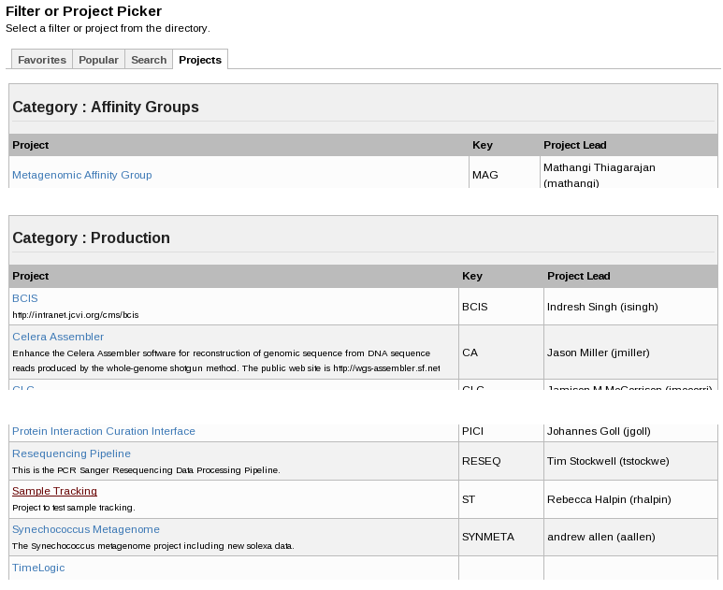
Illustration 5: The Project tab of the Project / Filter selection dialog

Statistics Type:
The drop-down menu for 'Statistics Type' contains a long list of fields that can be used to categorize the issues selected by the project or filter. For the example select 'Status' from the list and click the button marked 'Next'. This will produce the page that contains the chart in Illustration 6: The top of the Samples per State Chart and Illustration 7: The bottom of the Samples per State Chart.
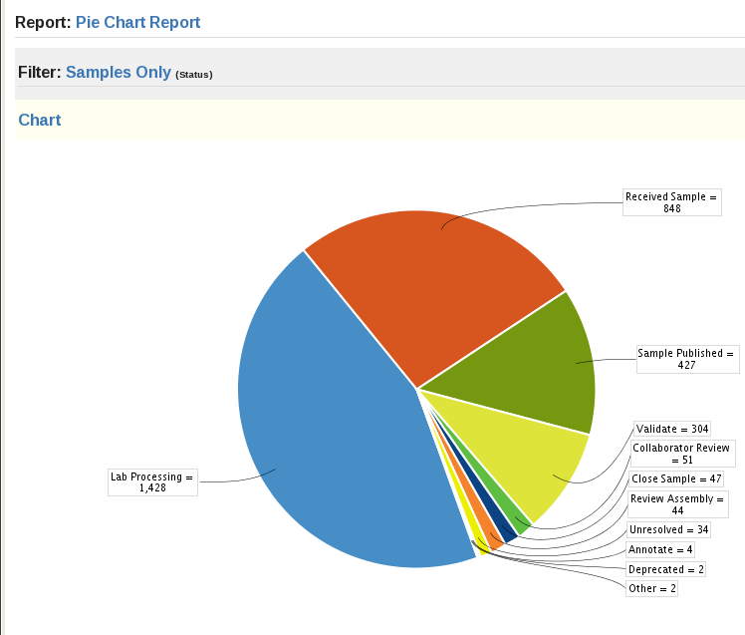
Illustration 6: The top of the Samples per State Chart
Each segment is a link to the Project Navigator page. Clicking on a segment will open the Project Navigator page with a search that displays only the samples that are in the segment selected.
Below the pie chart is a table summarizing the data from the chart. The numbers in the 'Issues' column also act as links to the Project Navigator page.

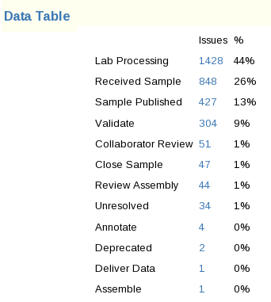
Illustration 7: The bottom of the Samples per State Chart

